22.49: a) The conductor has the surface charge density on BOTH sides, so it has twice the enclosed charge and twice the electric field.
b) We have a conductor with surface charge density on both sides. Thus the electric field outside the plate is 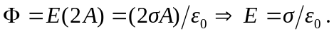 To find the field inside the conductor use a Gaussian surface that has one face inside the conductor, and one outside.
Then:

